What the font means
***DON’T FREEK OUT WHEN YOU SEE RED or BOLD FONTS ! , I LIKE TO USE IT TO HIGHLIGHT OR SHOW IMPORTANCE.
Red is something I need to discuss
Blue is for future round
Green is something we discussed and pending an action
Grey is something we discussed already

Database Instructions
- All tables should have prefixes, in some cases suffixes. This is to organize similar tables close together and define what they do with codes. This makes it easy to support.
- When defining columns, go ahead and make them all TEXT for character. TEXT does not limit the size, but we will enforce the size on the app layer.
- Make small tables like look up tables identity fields SMALLINT. Make record identity fields BIGINT.
Saw this in the design, Primary keys need to be BIG INT. See link below. There is risk if we ever do database sharding across multiple databases down the road. For now, use BIGINT until we cross that bridge. We may use both if really needed for external security like for URL. We will do this on a case-by-case basis.
postgresql should i use bigint or guid for primary key - Google Search
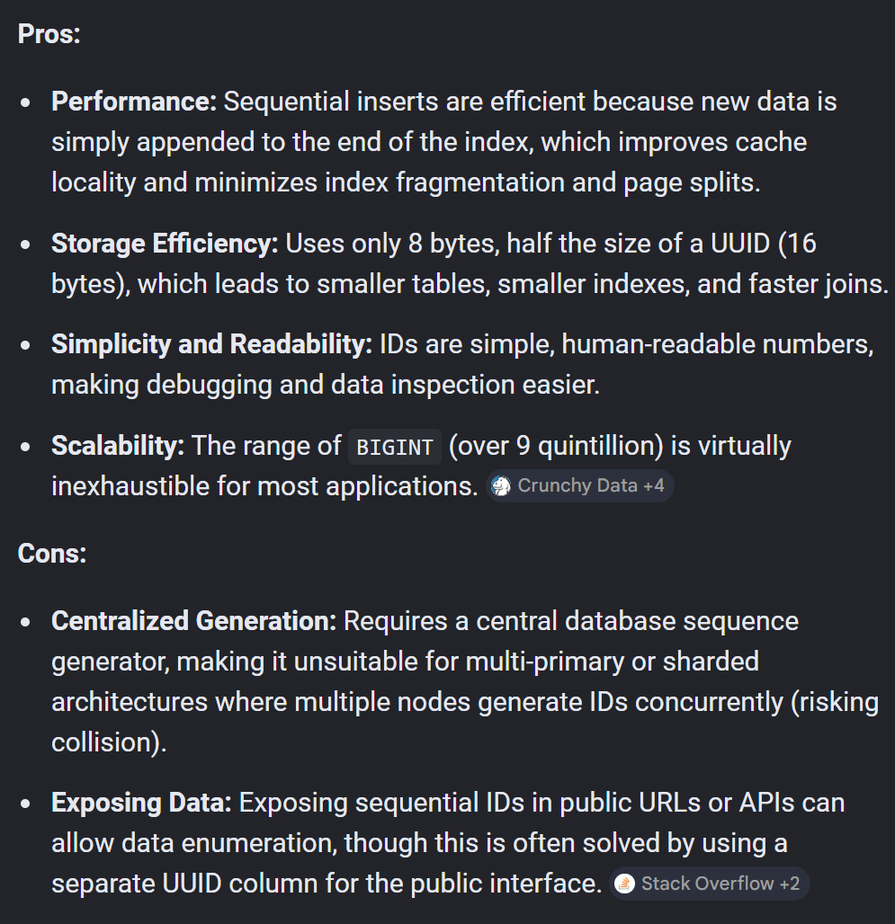
Don’t perform joins on Guid without consulting me
Don’t create a clustered index on GUID
postgresql should i create a clustered GUID index - Google Search

… change the business PK and FK to BIGINT for BusinessID
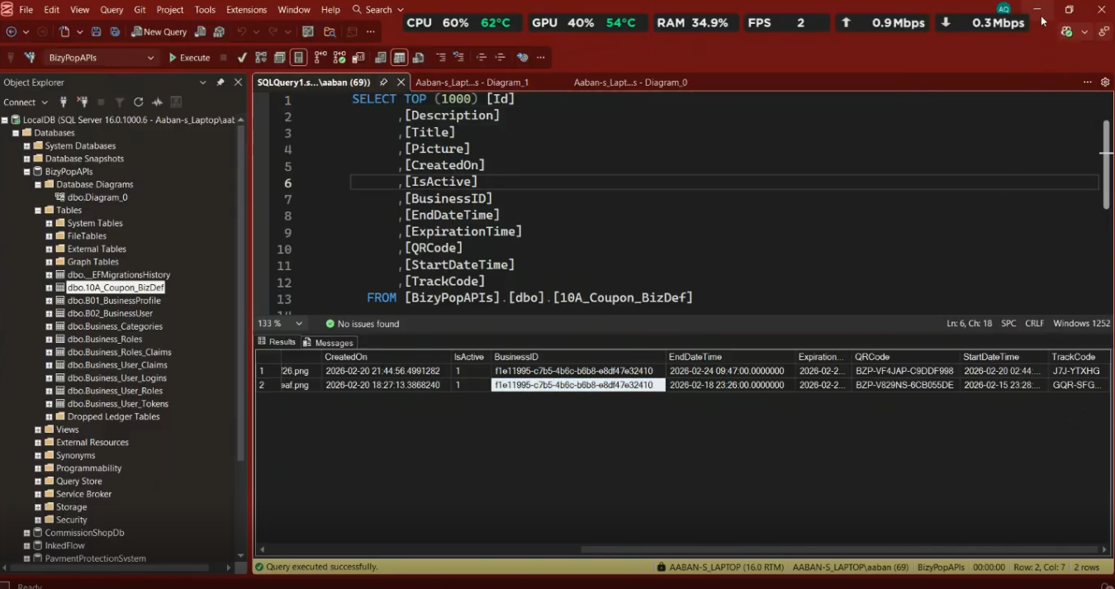
- Make the database text search case INSENSITIVE. PostSQL is case sensitive by default (SQL Server is the opposite).
- Create the B01_BusinessProfile table.
- This is where the profile information will be stored.
- (see access)
- Create another table called 1000_SysPhotoInfo
  - See (access)
  - Profile photo and business photos.
  - Do not store the photos in the database!
    - Read recommended approach section: postgresql should i store photos in a separate table - Google Search
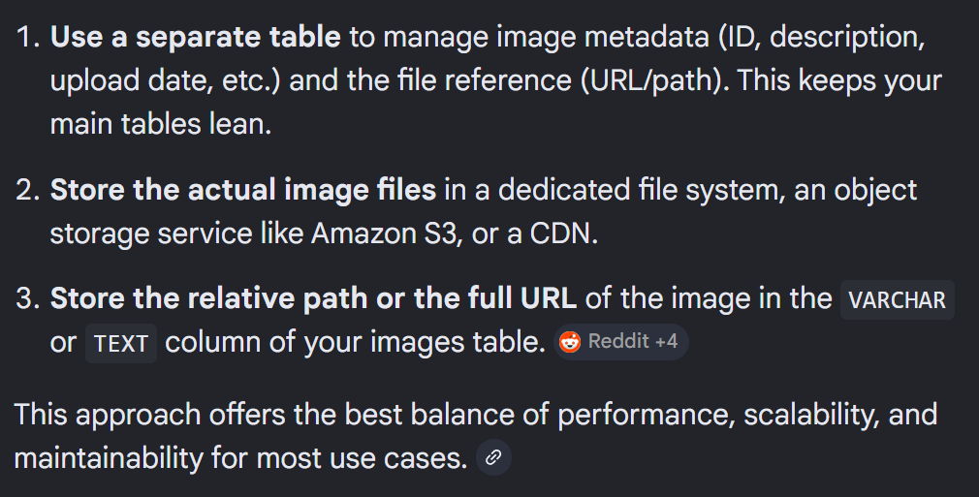
- We will have a CloudFlare CDN service eventually for the photos, in the meantime, figureout a temp URL. Maybe Google Drive or FaceBook or the internal webserver.
- Create the table B02_BusinessUser
(see access table)
- Create table B03_BusinessUserLink
This is the linking table for table 200 and table 210. It is a 1:many relationship. Businesss:Users. A business can have many users.
- Create table 00LK1_IncentiveType
(see access table).
This table is used to store the ID of the incentive type. When using filtering and selecting incentive, it is better to search by ID instead of character, etc. It is also better to join by ID. This is

Rename these tables. Every table needs a prefix.
Business_Categories = B00LK_BusinessCategories
Business_Roles = B10_Business_Roles
Business_User_Roles = B11_Business_User_Roles
Business_Role_Claims = B12_Business_Role_Claims (prebuilt table that handles access control)
Business_User_Logins = B20_Business_User_Logins
Business_User_Tokens = B21_Business_User_Tokens

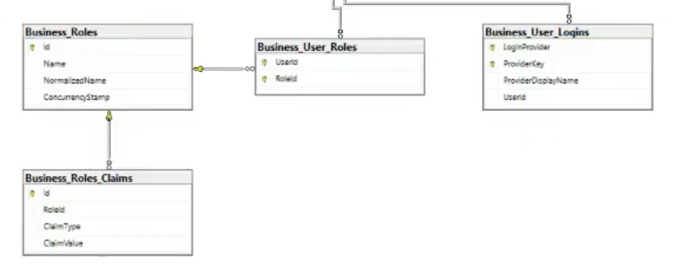

Need to understand what the claims tables do.
There is a script to create permissions, we can do in round 2.

Rename the format of QR code
There are many QR code usage in the database reflecting different tables, so the QR scan will search different tables. You want the 3 charater prefix to be the name of the table that the system will search.
The format will be like below:
The APP, in this case
“BZP-”
Followed by table prefix, so if a user wants to go to a business BizyPop info page, it will be “B01-“ This tells the engine which table to look in, in this case, “B01-BusinessProfile”.
Followed by random characters.
BZP-B01-SDKLJS-0SFADFDA

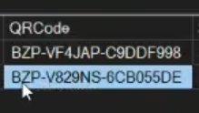

(Green Fonts means reviewed already, but not built, can skip until later)
Returning newly created ID back to the application
Need to discuss this:
OPTION 1.
in postgresql if i create a new record with a new primary key stored as bigint, how do I retrieve it from the application - Google Search
OPTION 2.
*When creating a new record, the GUID should be created from the APP and put in the DB. The only reason for this is to retrieve the primary key which is a BIGINT. To fetch the record, you would search by GUID, then use the BIGINT primary key.

